TUGAS 7

Nama : Andi Sri Mulyani Ananda Halilintar

# Add French as a supported language

In this section, add a supported language to the call flow, create a language menu and set it as the starting menu, and add a reusable task for the French language.

1. In the Settings area, click **Supported Languages**.

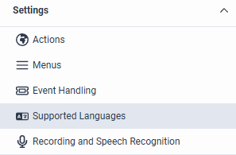

1. In the Supported Languages configuration area, click **Add Language** and select**French Canada**

**(fr-CA).**

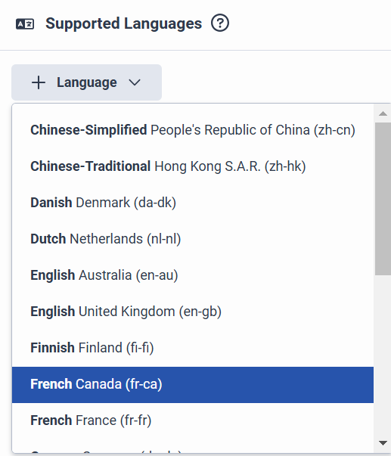

# Create a new menu and set it as the starting menu

1. From the Toolbox, expand the Menu category and drag a Menu action into the Reusable Menus area.
2. In the Name text box, type Prompt for Language.

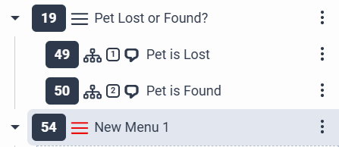



1. Click Set this as the starting menu.

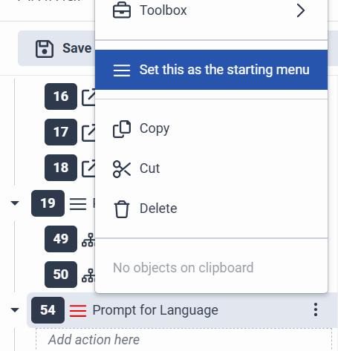

1. In the Prompt for Language Starting Menu design area, in the Menu Prompt box type Prompt.GCACContinueEnFrancais. This prompt plays the following message to the caller: “To continue in French, press 2.”

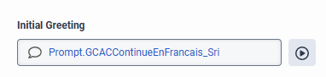

# Add a reusable task to change the language to French

Add a reusable task to change the language to French

1. From the Toolbox, expand the Task category and drag a Task action into the Reusable Tasks area.

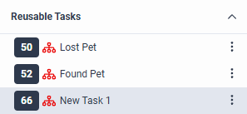

1. In the Name field, type Change to Fíench and then click Edit ľask. Aíchitect opens the task editoí



1. In the Name field, type Change to French and then click Edit Task. Architect opens the task editor.

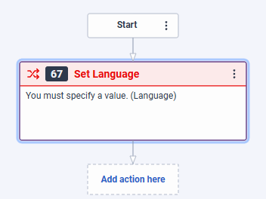

* 1. In the Name text box, type Change to French

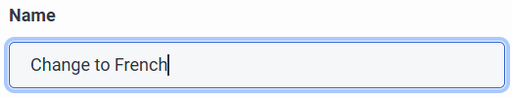

* 1. In the Select Language box, choose French (Canada) (fr-CA)

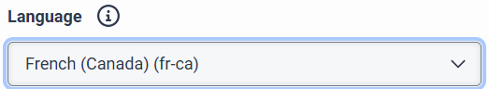

1. From the Toolbox, expand the Menu category and drag a Jump to Menu action below the Set Language action and complete the following steps:

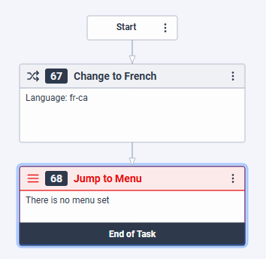

* 1. In the Name field type Jump to Emergency Menu

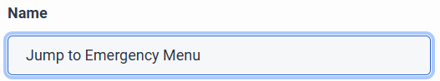

* 1. Click Menu and select Emergency Menu

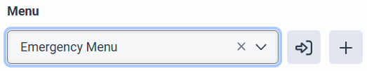

1. Click Return to Overview

# Add the Change to French reusable task to the starting menu

1. Drag a Jump to Reusable Task into the Prompt for Language menu and change the name to Opted for French

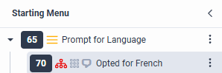

1. Select a DTMF of 1 and add French as a speech recognition term in the English box and

Français in the French box

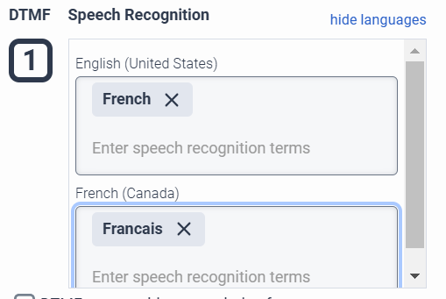

1. Select the Change to French reusable task

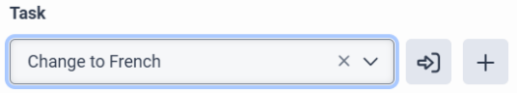

1. Save your work



# Add a menu choice for non-French calls

1. Drag a Jump to Menu action into the Prompt for Language menu. This action is located in the Menu category

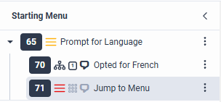

1. Change the name to English language calls



1. Select a DTMF of 0

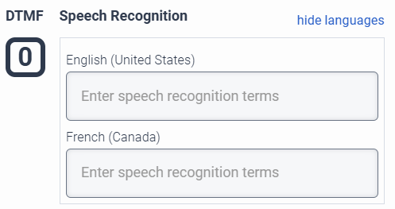

1. Leave the remaining settings unchanged and save your work

